

**Project Programming (**[**Project Remember**](https://github.com/Al-Rakan/Project_Rember)**)**

By: Rakan Al-Khaled

Under the supervision of His Excellency Dr. NOOR UZ ZAMA KHAN

**CONTENTS**

Introduction ..…………. 1-1

Abstract ………………. 1-2

Algorithm ………….…. 1-3

Explain………………... 1-4

Program Code ……..…. 1-5

**Introduction**

**1-1**

**In the beginning, I chose the** [**Python language**](https://www.python.org/) **because it is one of the most famous and powerful languages at the present time and helps me implement my ideas and develop software in an easier, faster and stronger way.**

**I used the** [**GitHub**](https://github.com/) **platform to upload the project**

**GitHub Inc is a platform and cloud-based service for software development and version control using Git, allowing developers to store and manage their code.**

**I used the editor "VS"** [**Visual Studio Code**](https://code.visualstudio.com/)**, also commonly referred to as VS Code, is a source-code editor developed by Microsoft for Windows, Linux and macOS. Features include support for debugging, syntax highlighting, intelligent code completion, snippets, code refactoring, and embedded Git.**

**Abstract**

**2-1**

**This Is Rakan from KSU today I want to Show you my project It is about programming And I am Crate Script programming Its function is to remind people of God through computer notifications, where they can choose the time, number of calls, and phrases such as “Subhan Allah”, “Alhamdulillah” etc.**

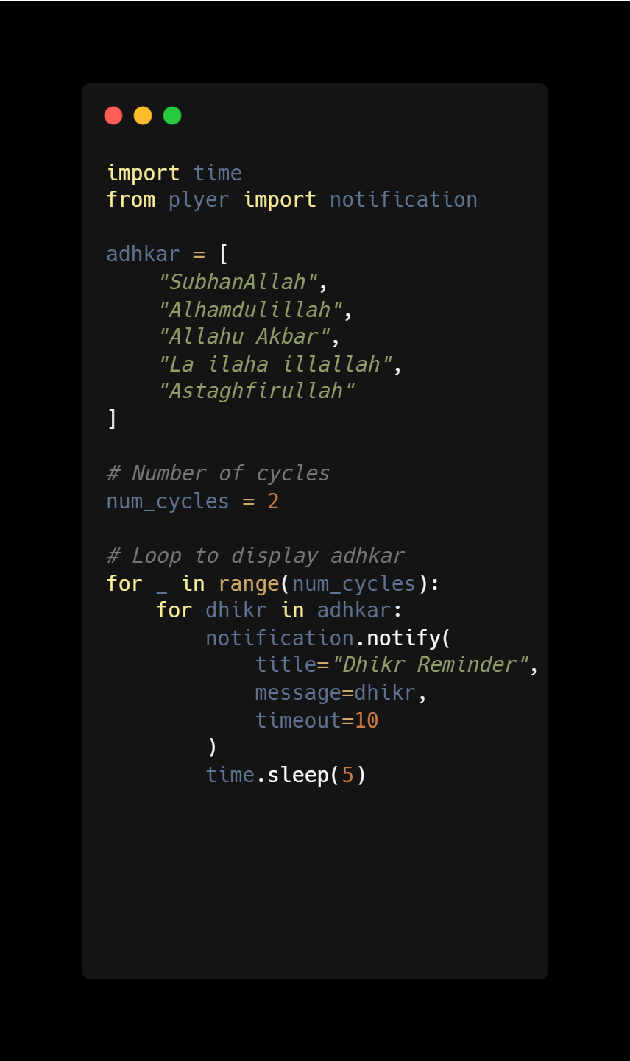

**3-1**

**Algorithm**

**Step 1: Start**

**Step 2: Input Text Type string**

**Step 3: if add it you can run the script and see the result**

**Step 4: Stop**

**4-1**

**Explain**

**Step 1: Start**

**Step 2: Crate A New Plank and Select .py 🡪 extension Python**

**Step 3: Entry Data 🡪 Input**

**Step 4: Set Roles Algorithms click to run Script and Its Run Auto**

**Step 5: Output The result stop.**

**5-1**

**Program Code**

|  |
| --- |
| **import** **time**  **from** **plyer** **import** notification  adhkar = [  "SubhanAllah",  "Alhamdulillah",  "Allahu Akbar",  "La ilaha illallah",  "Astaghfirullah"  ]  # Number of cycles  num_cycles = **2**  # Loop to display adhkar  **for** _ **in** range(num_cycles):  **for** dhikr **in** adhkar:  notification.notify(  title="Dhikr Reminder",  message=dhikr,  timeout=**10**  )  time.sleep(**5**) |